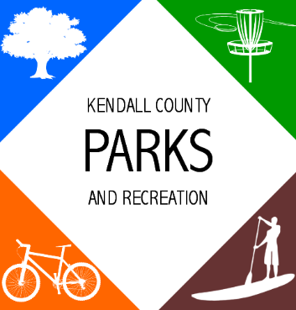
AGENDA
Parks Advisory Board Meeting
11:00 AM- June 24, 2021

Ring Mountain Event Center
716 FM 289 Comfort, TX 78013

- Call to Order
- Public Comments
- Approval of Minutes
1. Adoption of Minutes
Parks Advisory Board – May 20, 2021 - Minutes
- Announcements/Reminders
- Staff Reports
1. Traffic Counts
2. Disc Golf Course Update
3. Winter Storm Update
- Consideration & Action
1. Establish groups for natural resources, Parks Master Plan, and a 501c3
2. Conduct a workshop with the Commissioners Court
3. Partner with Comfort Area Foundation
- Other Business
1. Parks Master Plan Updates
2. Comfort Park Maintenance Agreement
3. Bond Election Poll
4. Budget FY 2022
5. Comfort Vision 2050 Parks Recommendation
6. Awareness for Parks
- Future Agenda Items
- Adjournment

